Любченко Олег 35 група

Завдання 1  
#include <iostream>

#include <conio.h>

using namespace std;

struct Book {

    char title[50];

    char author[50];

    float price;

};

int main() {

    Book books[10]; // Масив структур книг

    int numBooks;

    cout << "Enter the number of books: ";

    cin >> numBooks;

    cin.ignore(); // Очистка буфера вводу

    for (int i = 0; i < numBooks; ++i) {

        cout << "Enter author of book " << i + 1 << ": ";

        cin.getline(books[i].author, sizeof(books[i].author));

        cout << "Enter title of book " << i + 1 << ": ";

        cin.getline(books[i].title, sizeof(books[i].title));

        cout << "Enter price of book " << i + 1 << ": ";

        cin >> books[i].price;

        cin.ignore(); // Очистка буфера вводу

    }

    cout << "\nBooks in the store:\n";

    for (int i = 0; i < numBooks; ++i) {

        cout << "Book " << i + 1 << ": " << books[i].title << " by " << books[i].author << ", Price: $" << books[i].price << endl;

    }

    _getch();

    return 0;

}

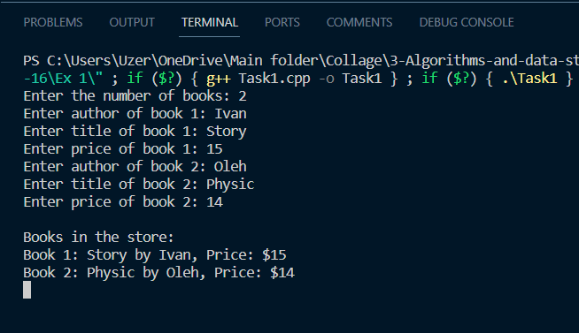  
  
#include <iostream>

#include <conio.h>

using namespace std;

struct Student {

    char fio[32]; // прізвище

    int birthDate; //дата народження

    int course; //курс

    double scholarship; // розмір стипендії

};

int main() {

    Student students[100]; // Масив структур студентів

    int numStudents;

    cout << "Enter the number of students: ";

    cin >> numStudents;

    cin.ignore(); // Очистка буфера вводу

    for (int i = 0; i < numStudents; ++i) {

        cout << "Enter full name of student " << i + 1 << ": ";

        cin.getline(students[i].fio, sizeof(students[i].fio));

        cout << "Enter birth date of student " << i + 1 << ": ";

        cin >> students[i].birthDate;

        cout << "Enter course of student " << i + 1 << ": ";

        cin >> students[i].course;

        cout << "Enter scholarship of student " << i + 1 << ": ";

        cin >> students[i].scholarship;

        cin.ignore(); // Очистка буфера вводу

    }

    cout << "\nList of students:\n";

    for (int i = 0; i < numStudents; ++i) {

        cout << "Student " << i + 1 << ": " << students[i].fio << ", Birth Date: " << students[i].birthDate << ", Course: " << students[i].course << ", Scholarship: $" << students[i].scholarship << endl;

    }

    _getch();

    return 0;

}

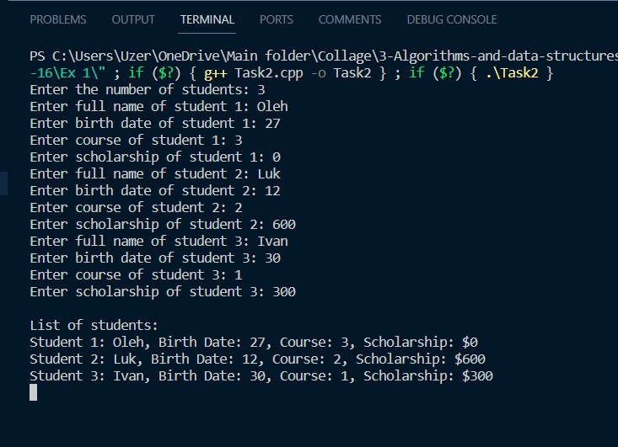

Завдання 2 (Варіант 14)  
#include <iostream>

using namespace std;

struct Employee {

    char name[50];

    int hoursWorked;

    float hourlyRate;

};

int main() {

    const float taxRate = 0.12; // Ставка податку

    int numEmployees;

    cout << "Enter the number of employees: ";

    cin >> numEmployees;

    Employee employees[numEmployees];

    for (int i = 0; i < numEmployees; ++i) {

        cout << "Enter name of employee " << i + 1 << ": ";

        cin >> employees[i].name;

        cout << "Enter hours worked by employee " << i + 1 << ": ";

        cin >> employees[i].hoursWorked;

        cout << "Enter hourly rate of employee " << i + 1 << ": ";

        cin >> employees[i].hourlyRate;

    }

    cout << "\nEmployee Payroll:\n";

    for (int i = 0; i < numEmployees; ++i) {

        float earnings;

        if (employees[i].hoursWorked > 144) {

            earnings = 144 * employees[i].hourlyRate + (employees[i].hoursWorked - 144) * employees[i].hourlyRate * 2;

        } else {

            earnings = employees[i].hoursWorked * employees[i].hourlyRate;

        }

        float tax = earnings * taxRate;

        float netPay = earnings - tax;

        cout << "Employee " << employees[i].name << ", Earnings: $" << earnings << ", Tax: $" << tax << ", Net Pay: $" << netPay << endl;

    }

    return 0;

}

